MINUTES
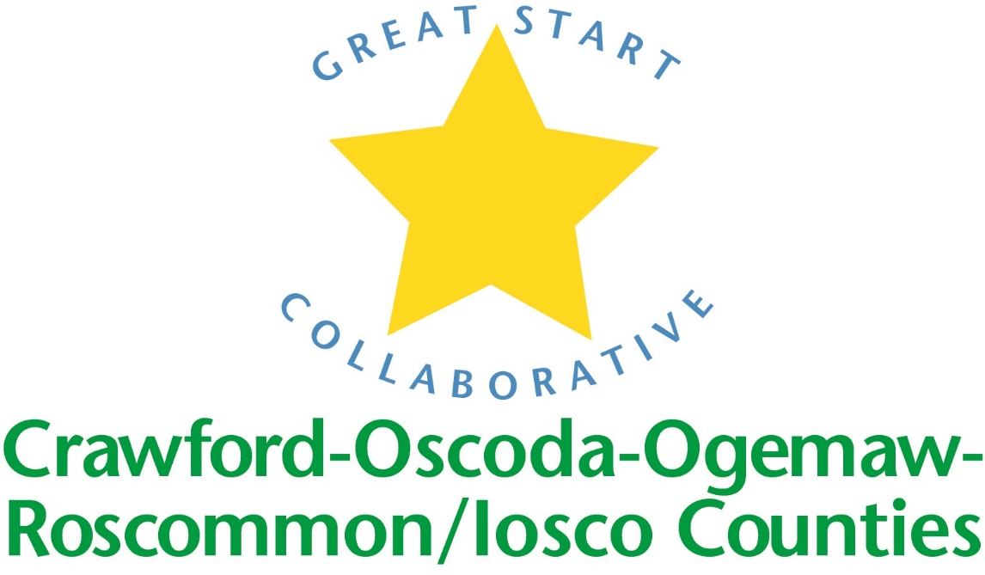

GREAT START COLLABORATIVE

Iosco RESA

May 19th, 2017
Amy Coulter, Great Start Parent Liaison called the meeting to order at 10:05 A.M.

MEMBERS PRESENT:
Allison Oakes, Phyllis Rhodes, Lorie Holton, Amy Coulter, Jan Akerman, Lisa Bellor, Rhonda Kuehn, Mary Kreft

Phone IN Members PRESENT:
Amy Mason, Lauren Carry

Approval of MINUTES
Lorie Holton, supported by B.J. Brandt.

Update on Early Childhood Conference
Sixty-five people in attendance. Good feedback was received from surveys. The conference had representation from five counties. People enjoyed it! The attendance was low, the date may have conflicted with other events. The main audience was childcare providers.

Parent Engagement- We should work more with the Regional Resource Center to have providers engage parents. Other places to engage parents may be DHHS, Commission on Aging. In-home visitors & Baby Pantries. Incentives should be given for parent involvement

Strengthening families
Amy & Phyllis attended SF training. Early On & Early Childhood teams need to get parents to attend the training. Strengthening Families focuses on the five protective factors. Phyllis will set up trainings in Ogemaw & Iosco Counties. In 2018, Strengthening Families Assessment will take place. Parents will have 1 ½ day training and return to Parent Cafes. Parents may lead Parent Cafes. Gas cards & food may be provided as incentives. Other Agencies may be able to provide these supports.

Trusted Advisors Grant
COOR-Iosco GSC applied for all $60,000.00. The Mom Power program is proposed thru Munson Hospital for high-risk families. There will be a ten week curriculum with a different focus each week. This program can support twelve families. The Talking is teaching program helps build vocabulary through everyday activities. Dr. Jo & Baby Pantries would support this. Literacy night will be planned. A literacy expert will show parents how to read to their children. Families will be educated regarding the third grade reading law. Jan Ackerman at IRESA has a literacy curriculum.

FY17/18 Meeting dates
COOR-Iosco GSC meetings will take place on Fridays in the months of Sept., Nov., Jan., March & May. COOR GSC meetings will be on different Fridays than Iosco GSC meetings.

Scholarships:
More participation from private providers is needed. Providers should attend 3 out of 5 GSC meetings to be eligible to receive scholarships. They need to be given ample notice of the meetings. Maybe a formal blog can be set up if people cannot attend the meetings. What barriers prevent providers from attending GSC meetings?

End joint meeting.

Iosco Updates
- Great Start to Quality- Providers in our counties have increased in participation, about 60%. A good increase in quality was seen.
- B. J. Brandt is the new Early On Coordinator in Iosco County.

School readiness advisory committee:
- Spring PQA scores were done in GSRP & other classes. The average score was 4.69 in
- Tawas & Oscoda. Goals were developed, assessment & teaching strategies-gold. Skill mastery & child group activities were developed. Outdoor equipment can help develop gross & fine motor skills.
- Transition should include visits to the kindergarten classroom, school library, gym and cafeteria. Speech, language, OT & PT screenings can make transition a smoother process. Other suggestions to make transition easier include parent meetings with the school success worker. Monthly school readiness activities could be given at home. Conferences and home visits should address school attendance & success.

Adjournment: 11:17pm

