MINUTES
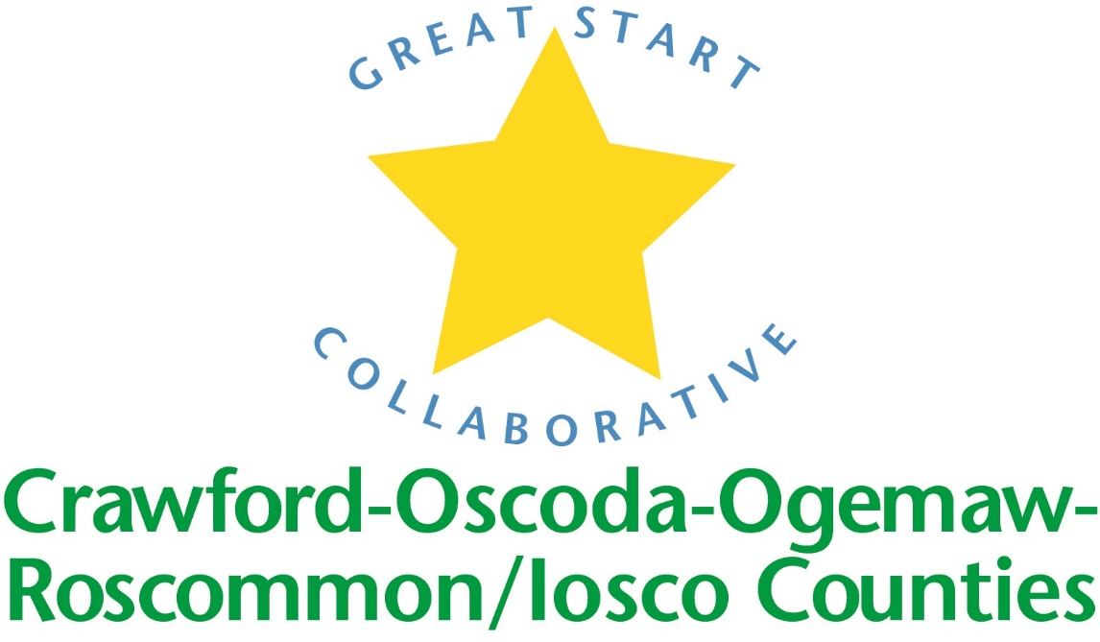

GREAT START COLLABORATIVE

Iosco Regional Educational Service Agency

January 11, 2017
Chris Tappan, Great Start Collaborative Coordinator called the meeting to order at 10:05 P.M.

MEMBERS PRESENT:
Phyllis Rhodes-GSC, Amy Coulter- GSC, Jan Ackerman-Iosco RESA, Lica Bellor-NEMCSA, Ellen Reeves-Tawas HeadStart, Kim Wenkel-WP NEMCSA, Kim Darlington-WP NEMCSA, Robin Vance-Head Start, Eric Allshore-Oscoda Area Schools, Mary Young-Oscoda 3 Head Start, Peggy Liddell-Oscoda ECC, Rhonda Kuehn-NEMCSA, Allison Oakes-NEMCSA, Rhonda Robson-NEMCSA, Ashlie Pietras-NEMCSA

Phone IN Members PRESENT:
Amy Mason, Jamie LaMoria, Becky Powell

Approval ofAGENDA
Motion made by Ellen Reeves, seconded by Kim

Update on scholarship PrograM:
Funds have been depleted for both COOR counties and Iosco County. 48 total scholarships were awarded to families in COOR and Iosco areas. We were able to serve 8 more families with a scholarship by raising our income eligibility guidelines to 400%.

Update on Early Childhood Conference
Conference held on April 22, 2017 from 9:00-3:45 at Roscommon High School We are currently looking for a few more presenters and vendors. Vendors need to bring a door prize as their entry fee. $10 registration fee. Will waive fee for families that would like to attend but cannot cover the cost of the registration. Keynote will be Dr. Mark Sloane. We are still working on getting transportation from Iosco RESA to the conference.

Trusted Advisory Grant
Grant will be awarded to Parent Coalitions in the amount of $5000-$60,000. Purpose of grant is to increase and engage hard to reach parents in early childhood and to possible support existing programming. Still waiting on some more guidance from The Office of Great Start.

Ready4K App
The app is up and working. Parents should be receiving text messages 3 times a week regarding literacy. We would like to see more participation from Iosco County. Still accepting forms.
End of joint meeting

cnaa Presentiation
Will be presented in March.

Introductions and updates

School Readiness Advisory COmmittee
Amy led the workgroup on the Kindergarten Survey. She explained that we need to get good data from parents. Demographics information such as what preschool, and in what school district should be asked. There should be more detailed questions regarding kindergarten visits, dates, expectations & summer activities.

Kindergarten readiness should be defined: Academic proficiency vs. social-emotional skills. Parents should be asked about their child’s fine motor skills such as cutting with scissors or holding a pencil. They should be asked about social skills such as taking turns. Parent observation forms could be used. The survey could be broken down by academic, social skills and self help areas. The group discussed each question on the example survey and made recommendations to improve it. There are home providers running preschool programs in Iosco County. Grants are available for space, Creative Curriculum and High Scope. Each survey will be individualized. Survey results will be broken down by GSRP & Head start. Parent opinion regarding school readiness is important. Survey information should be shared with providers.

adjourned at 11:15 AM

Next meeting: Friday, March 17, 2017 at 12:00. Locations: Iosco RESA & Roscommon Middle School

