MINUTES
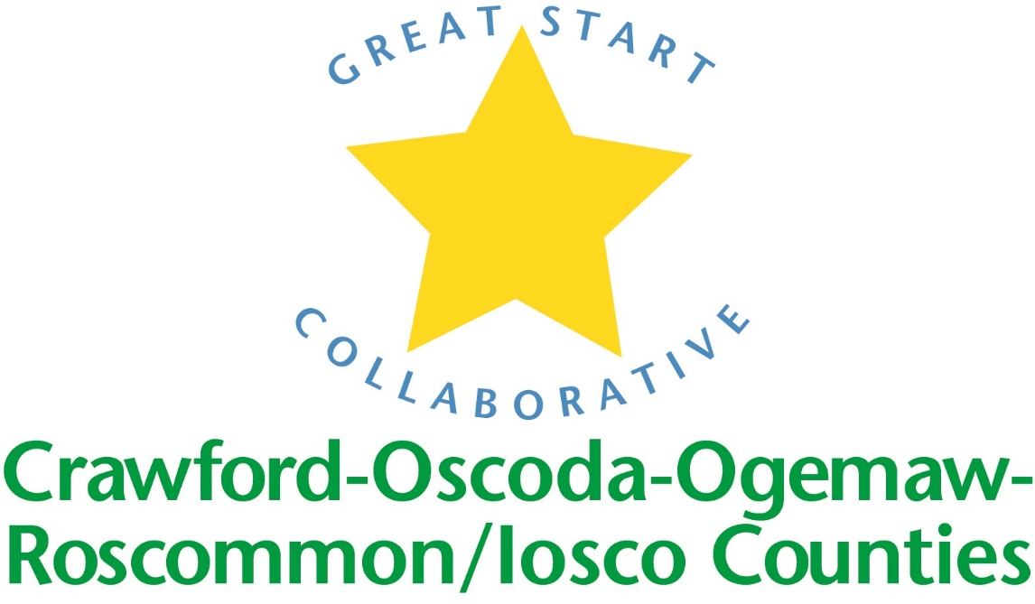

GREAT START COLLABORATIVE

Iosco RESA

March 17th, 2017
Amy Coulter, Great Start Parent Liaison called the meeting to order at 10:05 A.M.

MEMBERS PRESENT:
Phyllis Rhodes, Chris Tappan, Lorie Holton, Kim Darlington, Barb Deaderstadt, Melissa Maeder, Tammy Kramer, Kim Wenkel, Rhonda Robson, Eric Allshouse, Kim Farver, Frau Sullivan, Mike Peach, BJ Brandt, Rhonda Kuehn, Allison Oakes, Lisa Bellor, Lindsay Dombek

Phone IN Members PRESENT:
Amy Mason, Lauren Carry

Approval of MINUTES
Minutes corrected by Kim Darlington. Motion by, supported by Kim Darlington.

Update on scholarship Parent Survey:
In February, all 48 families that received a scholarship were mailed a parent survey to gather data and input. 24 were returned. The majority of the families were not interested in parenting classes, but the ones that were are interested in SF and Social Emotional training. The resources that parents with young children found most beneficial are Preschools, Playgroups and Libraries. The resources that parents found lacking in their area are Preschools, Child Care, Community Centers, Activities for families during non working hours, and opportunities for over income families.

Update on Early Childhood Conference
Conference held on April 22, 2017 from 9:00-3:45 at Roscommon High School Registration is now open. Keynote address by Dr. Mark Sloane on Understanding Complex Children with Prenatal Exposure and Toxic Stress. Breakout sessions include: Overview of Collaborative Interdisciplinary Treatment in Complex Young Children, Essential Roles of School and Home Visitor Staff for Complex Young Children with Behavioral Challenges, Creating Leaders in the Infant/Toddler Classroom, Helping Children with Self-Regulation, Science for Young Minds, Positive Guidance and Discipline, Enhanced Outdoor Learning, MTSS: Cooperation, Prevention and Interventions, Working with Diverse Parents in the Infant/Toddler Environment, Exploring Art for Early Learning, Healthier Childcare Environments, Story Telling and Teaching Children to Save.

Trusted Advisory Grant
Grant will be awarded to Parent Coalitions in the amount of $5000-$60,000. Purpose of grant is to increase and engage hard to reach parents in early childhood and to possible support existing programming. Still waiting on some more guidance from The Office of Great Start but it can be used for multiple projects.

MAKE UP OF GREAT START MEETING FOR FY18
For FY 18, there will be a GSC meeting held in Roscommon and then one in Tawas the following week (or within the same month). A calendar is being developed and all meetings will be held on Fridays.

KINDERGARTEN TRANSITION WEBSITE
COOR has worked on this and its up and running. This website on Livebinders was driven by the parents. Members were asked to test and play around on the website and provide feedback. Feedback is needed from Iosco on what need to be on the website.
End of joint meeting

Introductions and updates:

GSTQ: An infant/toddler parent survey is being widely distributed in their 11 counties. Distributed Quarterly Report. Qualifying programs can get up to $4500 in grant money each cycle. Kaplan and Lakeshore are giving discounts and free shipping.

Dolly Parton’s Imagination Library: Age appropriate books are mailed to the child’s home. This program is for 0-5 children in Alcona/Iosco. The group has applied for several grants and has been working on sending out a donation letter to the community.

Ideas for Trusted Advisors: Literacy – sending books home.

School Readiness Advisory COmmittee

Strategic goals and Creative Curriculum were discussed. Children should be taught organizational skills. Changes will be made to the parent survey and it will be sent out. Expectations of children entering kindergarten were discussed.- how do we come up with common definition of “readiness” between pre-k and kindergarten teachers? Parents need to know what will be expected of their child. Head Start students visit Kindergarten classrooms as a part of their transition.

Adjourned at 11:55

