MINUTES
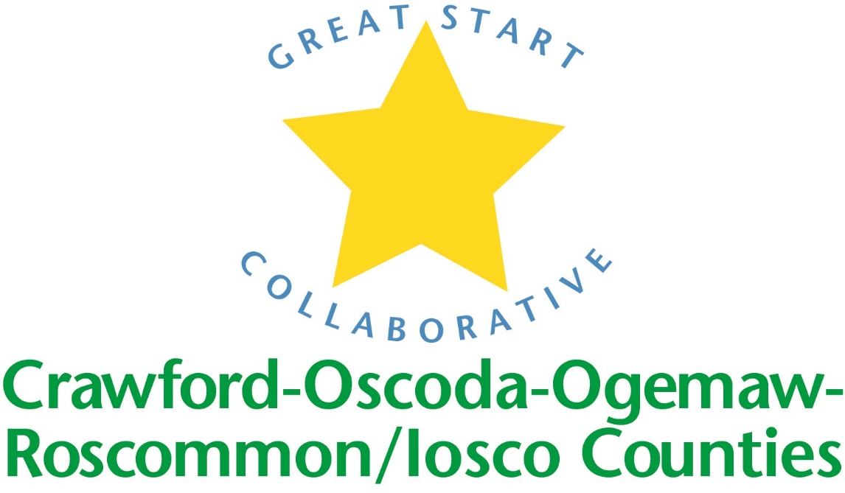

GREAT START COLLABORATIVE

ROSCOMMON MIDDLE SCHOOL

May 19, 2017
Christina Tappan, Great Start Collaborative Coordinator, called the meeting to order at 10:05 A.M.

MEMBERS PRESENT:
Melissa Maeder, Brooke DuBoe, Heather Benson, Sara Briggs, Salena Laskowski, Michele Cochrane, Gail Hughey, Stephanie Robison, Michelle Schepke, Kristin Carrick-Myers, Elizabeth Kachiros, Tammy Tyler, Jennifer Barnum, Kim Cherven, Sara Humphreys, Amy Mason, Sue Browder, Elizabeth Burtis, Gina Brunskill, Christina Tappan, Carmen Michels,

Phone IN Members PRESENT:
Becky Powell, Lauren Carry, Heidi Gross, Catherine Nickell Simpson,

Approval of MINUTES
Motion by Michelle Schepke, supported by Michele Cochrane to adopt the Minutes as presented.

Update on Early Childhood Conference:
65 people attended. 9 counties represented. We received good feedback from our breakout sessions and overall conference evaluations. Discussion on how to get our numbers back up; near 100 again. Will work closely with the Resource Center. Various ideas were presented on Keynote and sessions – possible rotation to specific population to target or offer a variety of tracks i.e. parent track, infant/toddler track etc.

Strengthening families
Amy and Phyllis attended train the trainer training at the end of April. They will be offering an overview training of the 5 Protective Factors to parents starting in the Fall. Amy is working with Michele Cochrane COOR’s Early On Coordinator and offering the first training to Early On Parents. Amy will focus on Crawford, Oscoda and Roscommon Counties. Phyllis will be focused in Ogemaw and Iosco Counties. Parent Café’s will also be organized and offered.

Trusted Advisory Grant
Grant was released at the end of March and submitted May 5th. We applied for all $60,000. The projects will include Mom Power: a 10 week parenting training for Moms. Moms will be identified by Munson Grayling’s OB department. Second project: Talking is Teaching and literacy campaign – activities included will be literacy training nights for parents. The training will teach parents how to read to their child.

MAKE UP OF GREAT START MEETING FOR FY18
Dates have not been set but meetings will be held during the months of: September, November, January, March, and May

Scholarship: Providers Paricipation
Discussion: We would like to see more participation from our programs receiving scholarship dollars and would like the group to consider voting on making it a requirement of the program that providers attend at least 3 meetings. Group decided to gather some information first from the programs regarding barriers to participation. Will still offer a conference call option. Look to record meeting and allow for providers to listen afterwards.
End of joint meeting

Introductions and updates:
Early On: Motion to approve Early ON grant. Motion made my Melissa Maeder and seconded by Gina Brunskill. Motion passed and Chris Tappan, GSC Coordinator will sign on behalf of the GSC for the 2017/2018 Early On Grant.

SCHOOL READINESS ADVISORY COMMITTEE
- Each program shared one kindergarten transition activity they conducted this year.
- There seems to be a deficit with enrollment in GSRP especially in Roscommon County. Chris and Amy will put up flyers throughout the county in hopes to reach families that have yet to enroll.

Adjourned at 12:04

