May 19, 2017 Agenda – 10:00 am
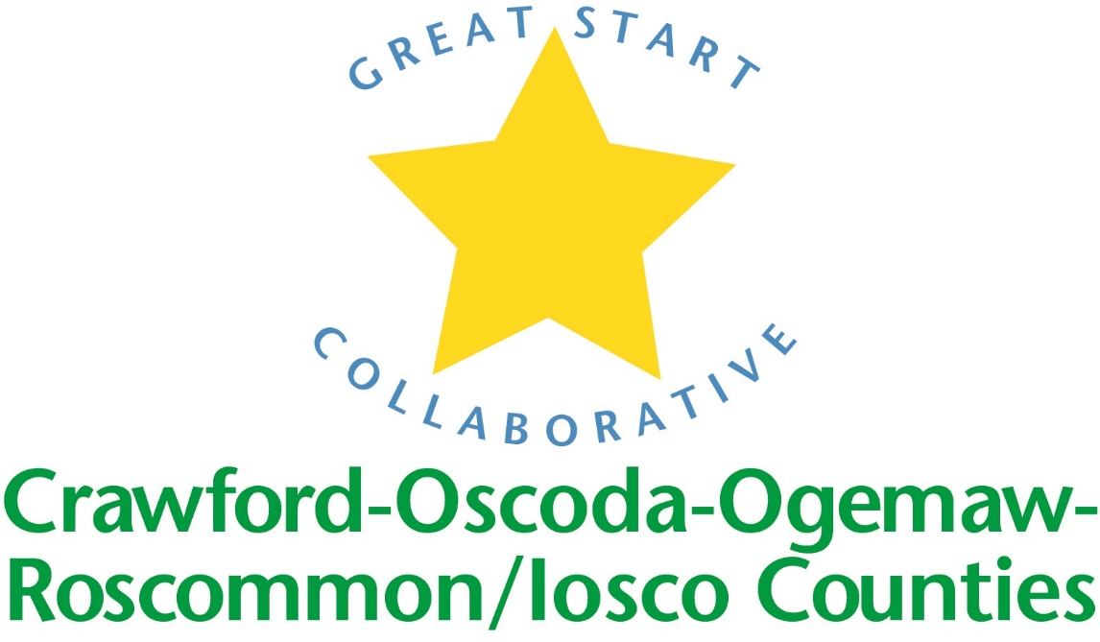

Location: Iosco RESA

Great Start Collaborative Meeting

For parent reps calling in:

Toll Free Number: 1 888 585 9008

Conference Room Number: 794-310-488

NORMS OF ENGAGEMENT:

● Open to other’s opinions and ideas

● Take care of your needs

● Consensus decision making

● Being respectful of each other’s time

● Everyone has a voice

● Time keeper-stay on schedule

● Keep phone muted

Call to Order

Welcome

Approval of Minutes from previous meeting
Motion by _____________________________, supported by ___________________________

4. Update of Early Childhood Conference

5. Strengthening Families

6. Trusted Advisory Grant

FY18 Meeting Dates

Scholarships: Providers Participation

End joint meeting updates – business carries on at each meeting site

Introductions and updates – limit to 2 minutes

School Readiness Advisory Committee

Spring PQA Scores- Rhonda R.

Transition activities: Allison and Lisa

Adjournment

Next meeting:

