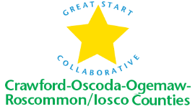
Great Start Collaborative Meeting Agenda
November 18, 2016
Roscommon Middle School
Iosco RESA
10:00-12:00

For parent reps calling in:
Toll Free Number: 1 888 585 9008
Conference Room Number: 794-310-488

NORMS OF ENGAGEMENT
- Open to other’s opinions & ideas
- Take care of your needs
- Consensus decision making
- Being respectful of each other’s time
- Everyone has a voice
- Time Keeper – stay on schedule
- Keep Phone Muted

- Welcome and introductions/updates

- Approval of Minutes

- Nominations for Chair and Secretary

IV. Email updates/events/trainings

V. Scholarships
- Update
- Income eligibility

VI. Early Childhood Conference
- Keynote
- Presenters
- Vendors
- Transportation/collaboration

VII. Ready4K!

VIII. Break into Workgroups
- Preschool Transition Group and Parenting Leadership Group
- What does this look like
- When will we meet
- Who should be involved
b. School Readiness Advisory Committee- Isoco
c. School Readiness Advisory Committee- COOR
- At Risk data
- website
d. 0-3 tracking workgroup - COOR
Adjourn
Next meeting: Friday, January 20th
Location: Roscommon Middle School and IRESA
Time: 10:00-12:00

