September 29, 2017 Agenda – 10:00 am
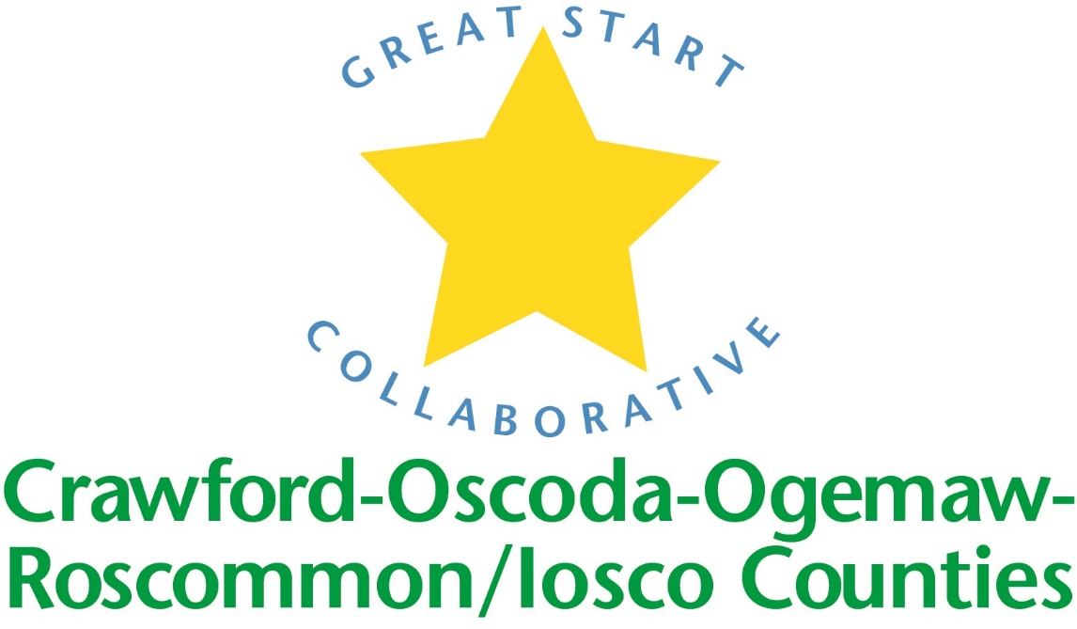

Location: Iosco RESA

Great Start Collaborative Meeting

For parent reps calling in:

Toll Free Number: 1 888 585 9008

Conference Room Number: 794-310-488

*2 to mute and unmute your phone

NORMS OF ENGAGEMENT:

● Open to other’s opinions and ideas

● Take care of your needs

● Consensus decision making

● Being respectful of each other’s time

● Everyone has a voice

● Time keeper-stay on schedule

● Keep phone muted

Call to Order

Welcome

Approval of Minutes from previous meeting

Motion by _____________________________, supported by ___________________________

Patti Peiffer - Michigan Special Education Mediation Program

Imagination Library

Trusted Advisors Grant

Early Childhood Conference-Conference Topics?

Introductions and updates – limit to 2 minutes

School Readiness Advisory Committee
- School Readiness Goals
- Local child care number
- Parent Engagement – Remind
- K transition survey – get out to local districts

Adjournment

Next meeting: Friday, November 10th, 2017

