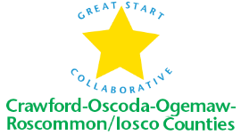
Great Start Collaborative Meeting Agenda
9/30/2016
Roscommon Middle School
10:00-12:00

For parent reps calling in:
Toll Free Number: 1 888 585 9008
Conference Room Number: 794-310-488
NORMS OF ENGAGEMENT
- Open to other’s opinions & ideas
- Take care of your needs
- Consensus decision making
- Being respectful of each other’s time
- Everyone has a voice
- Time Keeper – stay on schedule
- Keep Phone Muted

I. Welcome and introductions by Chris Tappan, Great Start Collaborative Coordinator and Karyn Rauch-Smock, Great Start Collaborative Chair

II. Approval of Minutes
III. Set up of Great Start Collaborative for the year
IV. Great Start Collaborative Activities for FY17
VII. Workgroups
- School Readiness Advisory Committee
- Kindergarten Transition Survey
- Kindergarten Website
B. 0-3 tracking workgroup
VII. Adjourn

Next Meeting: Friday, November 18, 2016
Location: Roscommon Middle School
Time: 10:00-12:00

